Survival science: learning through group interviews

Rainforest rally challenge

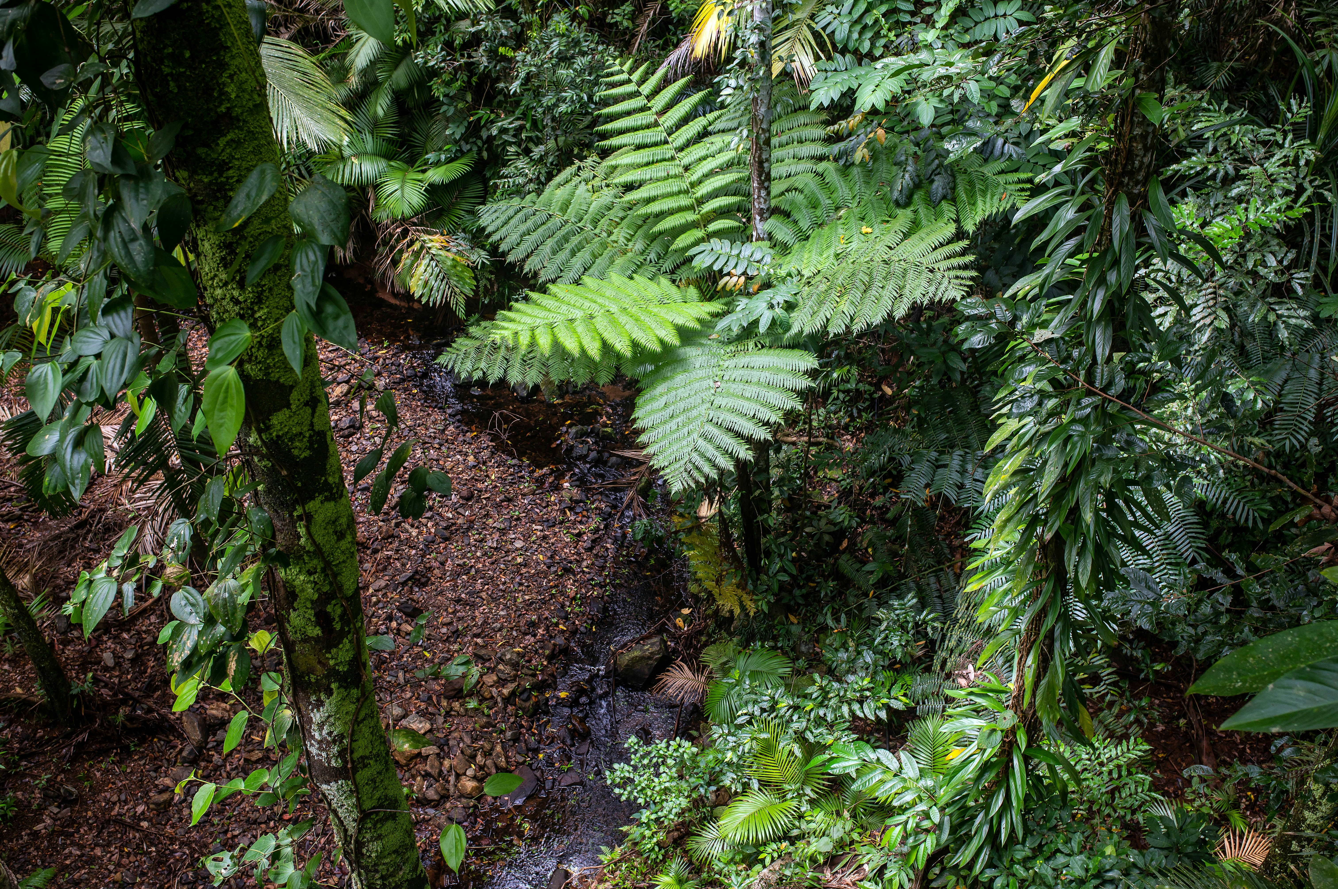You are a student volunteering for a conservationist organization in the Amazon rainforest. Deforestation due to industrialized farming, mining, and timber production has caused a catastrophe for ecosystems of flora and fauna. You have embarked on a five-day journey with four fellow volunteers into the depths of the forest to perform a biological survey of the environment, with a senior conservationist as your guide. However, on the third day of your journey, the guide is taken ill with a fever after consuming some wild berries. After a few hours of attempting to continue with the journey, the guide is forced to stop and soon falls into a delirium. One volunteer has decided to stay and treat the symptoms, while you are tasked with leading the remaining two volunteers back to base camp to seek help. The journey is perilous, as the base camp is located 50 km away, and you will be required to scale hilly terrain, along with crossing several rivers and streams. The temperature is 35°C during the day and the humidity is 80%, making the environment extremely damp. Each volunteer has with them a travel backpack and essential items of clothing.

Image: David Clode/[Unsplash,](https://unsplash.com/photos/a-lush-green-forest-filled-with-lots-of-trees-and-plants-ccu6RY3dbRg) [CC0](https://unsplash.com/license)

Below is a list of 15 items. Use your knowledge of science to list these items from most to least important. Place the number 1 by the most important item, the number 2 by the second most important, and so on, with number 15 as the least important. After the activity, you will receive the official ranking.

|  |  |
| --- | --- |
| **Item** | **Your ranking** |
| 5 kg of activated charcoal powder |  |
| 1 kg of canned food |  |
| Bandages and gauze pads |  |
| Two walkie talkies |  |
| Solar-powered UV water sterilizer |  |
| Inflatable raft |  |
| Two empty plastic bottles |  |
| Box with 16 antibiotic tablets |  |
| Large convex lens |  |
| Potassium permanganate crystals |  |
| Loaded hunting rifle |  |
| Bluetooth speaker |  |
| Pocket mirror |  |
| Chainsaw full of fuel |  |
| Can of insect repellent spray |  |