Supporting Information

Elements in danger!

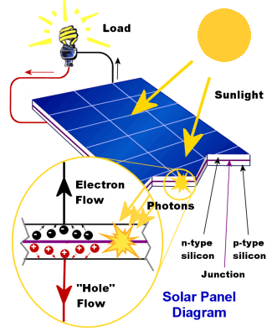
Box 1: Solar panels

Photovoltaic cells (PV cells) in solar panels work by absorbing specific wavelengths of the electromagnetic spectrum and using the energy to generate electron movement within a semiconductor (SC). The SC is formed of two different horizontal layers, one with a higher electron density and therefore a negative charge, and the other with a lower electron density and therefore a positive charge. When a photon is absorbed, an electron is moved from one layer to the other via a wire, creating a flow of electrons (i.e., a current). The electricity can power a device, be stored within a battery, or be transferred to the national supply.
Working mechanism of silicon solar cell
Tssenthi/Wikimedia, CC BY-SA 4.0

Box 2: Solar panels
Annual sales of plug-in passenger cars in the world's top country and regional markets between 2011 and 2020.
Mario Roberto Durán Ortiz/Wikimedia, CC BY-SA 4.0

A shift from combustion to electric power for vehicles in the next 30 years is almost guaranteed, with major players such as China, UK, India, Germany, and France announcing the banning of combustion fuel cars by 2050. This will drastically increase the demand for cobalt and lanthanum, since nickel-cobalt-aluminium and nickel-manganese-cobalt batteries are the current standard for this type of vehicle, with lanthanum being found in large quantities in the anodes of these batteries. Tesla are currently in talks with a Chinese battery supplier developing a lithium-iron-phosphate battery system.

Box 3: Electrolysis of aluminium
Electrochemical equations for the Hall–Héroult process and a cross-sectional cartoon of the smelting process.
Kashkhan/Wikimedia, CC BY-SA 3.0.
Hall–Héroult process
Cathode:
Al⁺³ + 3 e⁻ → Al
Anode:
2O⁻² + C → CO₂ + 2 e⁻
Overall:
2Al₂O₃ + 3C → 4Al + 3CO₂

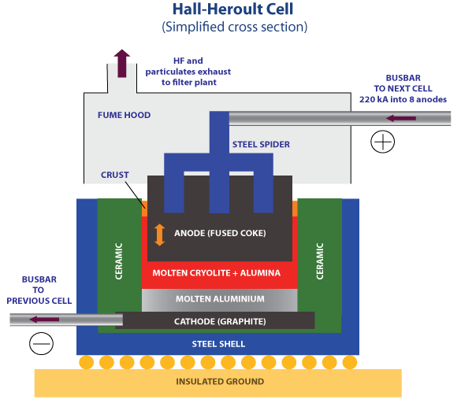
Electrolysis of aluminium (the Hall–Héroult process) uses direct electrical current (DC) to extract aluminium from its ore within an electrochemical cell. Aluminium oxide is produced from bauxite ore (impure aluminium oxide, Al₂O₃) using the Bayer process, which has a step that involves dissolving the bauxite in a sodium hydroxide solution. During this stage of the process, gallium accumulates in the sodium hydroxide and is subsequently extracted using a variety of methods. Since the concentrations of gallium are still low, it is not financially viable to mine gallium as the primary mineral.

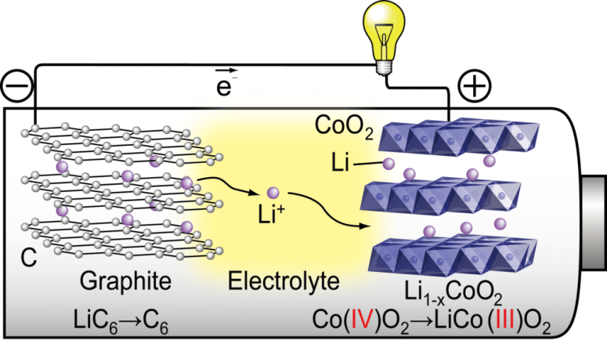
Box 4: Lithium-ion batteries
Lithium cobalt oxide battery. e⁻ represents free-electrons.
Reproduced with permission from D. T. Kawaguchi, Lithium-ion battery

Lithium cobalt oxide (LiCoO₂) batteries are currently one of the most widely used batteries in portable electronic devices due to their high conductivity, structural stability during charge cycling, and high specific energy (energy per unit mass). Cobalt oxide and graphite are stacked in layers, with lithium ions in between. These ions move through an electrolyte from the graphite anode to the cobalt cathode when discharging. Free electrons move from the now negatively charged graphite to the cobalt, changing the oxidation state of the cobalt from Co^{IV} to Co^{III}. The movement of free electrons through the circuit creates the current that powers the device. Lithium and cobalt are both ‘elements in danger’ and the ores that they are extracted from are both mined.

