Additional Material

Exponential growth 1: learning the basics from confetti to understand pandemics

Activity 1 – Confetti for a party
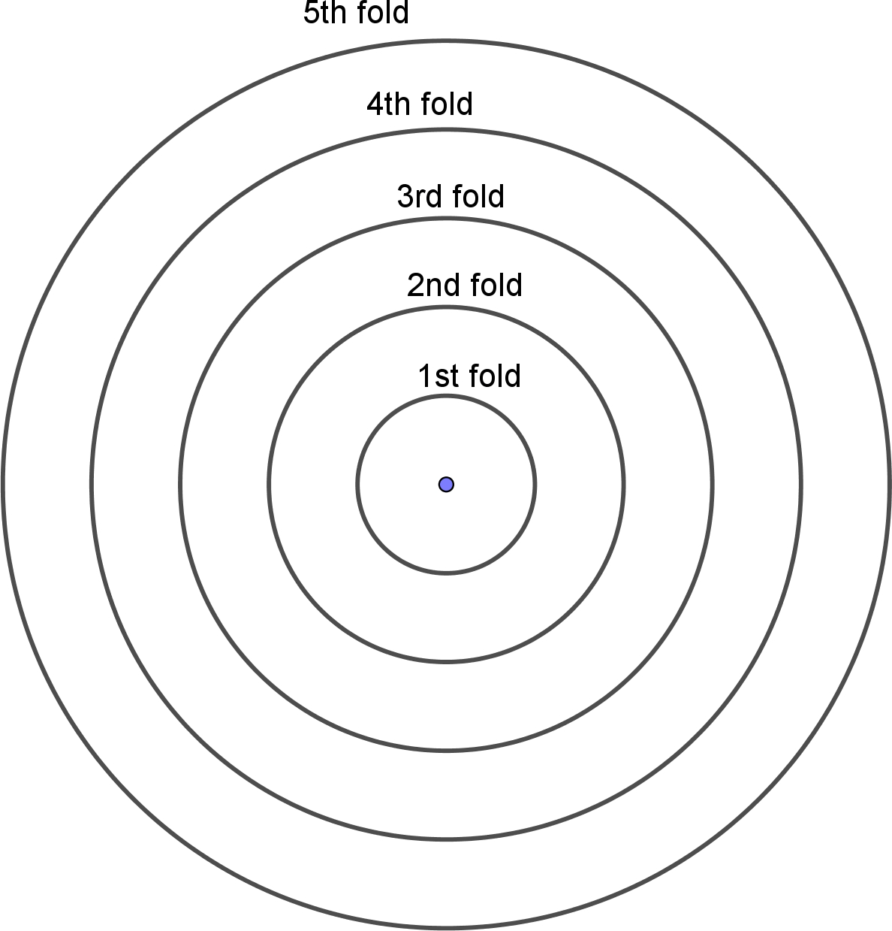
- Produce as much confetti as possible, as quickly as possible. For this you need a hole punch and paper. What is your strategy?

- On each circle, mark the number of confetti you’ll get after punching a sheet of paper folded the number of times indicated on the circle.

- Fill in Table 1 to find out more about the relationship between the number of folds and the number of confetti:
Number of folds | 0 | 1 | 2 | 3 | 4 | 5
Number of confetti obtained
Relationship
Table 1: Relationship between number of folds and confetti obtained

Activity 2 – Exponential growth in a pandemic

Part 1: Unhindered spread of COVID-19

Student information:
To follow the course of a disease, it must be known how many people, on average, are infected by an infected person if no precautions are taken. This ‘basic reproduction number’, called R₀, is about four for COVD-19. If mutations occur that make the virus more contagious, the R₀ value increases accordingly. For polio, the R₀ value is six; for measles, it is between 12 and 18.
In addition to R₀, the time, D, during which the infected person is infectious or during which they can infect other people also plays a role. For COVID-19, the value for D is about five days.
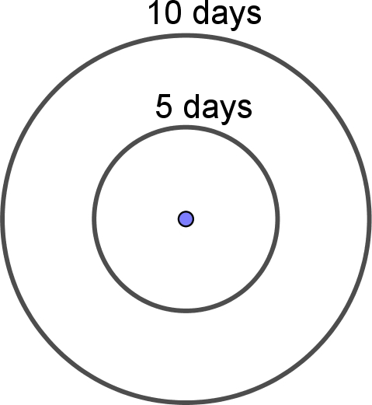
- In the COVID-19 pandemic, on average, one infected person infects four other people within five days. Plot the number of newly infected people on the diagram with concentric circles; each circle represents a time period of five days. On each circle, indicate each newly infected person as a dot. Also draw connecting lines between newly infected people and the infecting person.

- Complete the following table and use data in the table to plot points on the graph paper provided and connect the points with a curve.
Days | 0 | 5 | 10 | 15 | 20
Number of newly infected people | 1
Table 2: Modelling the spread of infection
- How many days does it takes for 4 (→16→64) newly infected people to become 8 (→32→128) newly infected people? This is the doubling time.
Your doubling time is:______
- Use the doubling time to complete this table:
Number of doublings | 0 | 1 | 2 | 3 | 4 | 5 | 6 | 7 | 8
Days | 0
Number of newly infected people
Table 3: Infection growth by doubling period
How many days will pass before 1 million people are newly infected?

Part 2: Containment of the COVID-19 pandemic

Student information:
Measures like physical distancing and use of face masks cause the infection to spread more slowly. This is expressed by the ‘effective reproduction number’, R.
These prevention measures will reduce the R value. If mobility, and thus the probability of contact and infection, is reduced by x %, then the effective reproduction number would be defined as R = (1−x/100) × R₀. This means that if mobility is restricted by 80%, then R is reduced to 20% of R₀. The use of a face mask to diminish aerosols also reduces the probability of infection by y % and affects the R value. Together, these two measures result in R = (1−x/100) × (1−y/100) × R₀.
- Use the Geogebra applet to find out more about how to contain the spread of COVID-19. With the help of sliders, you can modify the effects of physical distancing and face masks. You can also change the time at which each or both measures are implemented. You will find the applet here: https://www.geogebra.org/m/qavutkx5.
- How does the timing of the onset of the containment measure(s) change the course of the graph?
- How do the following containment measures affect the number of newly infected people?
- physical distancing only
- masks only
- both physical distancing and masks

