Extension Activity

Exponential growth 2: real-life lessons from the COVID-19 pandemic

Extension Activity 1 – Logarithmic scaling of a plot
In worksheet Activity 2, you were asked to draw a graph of exponential growth. The slope of this graph increases as x increases, so, from a certain x value onwards, the graph rises almost vertically. It is then hard to tell which R value forms the basis of the graphs.
The three graphs in the plot below all show exponential growth.
- Which graphs correspond to R values of 5, 6, and 7?

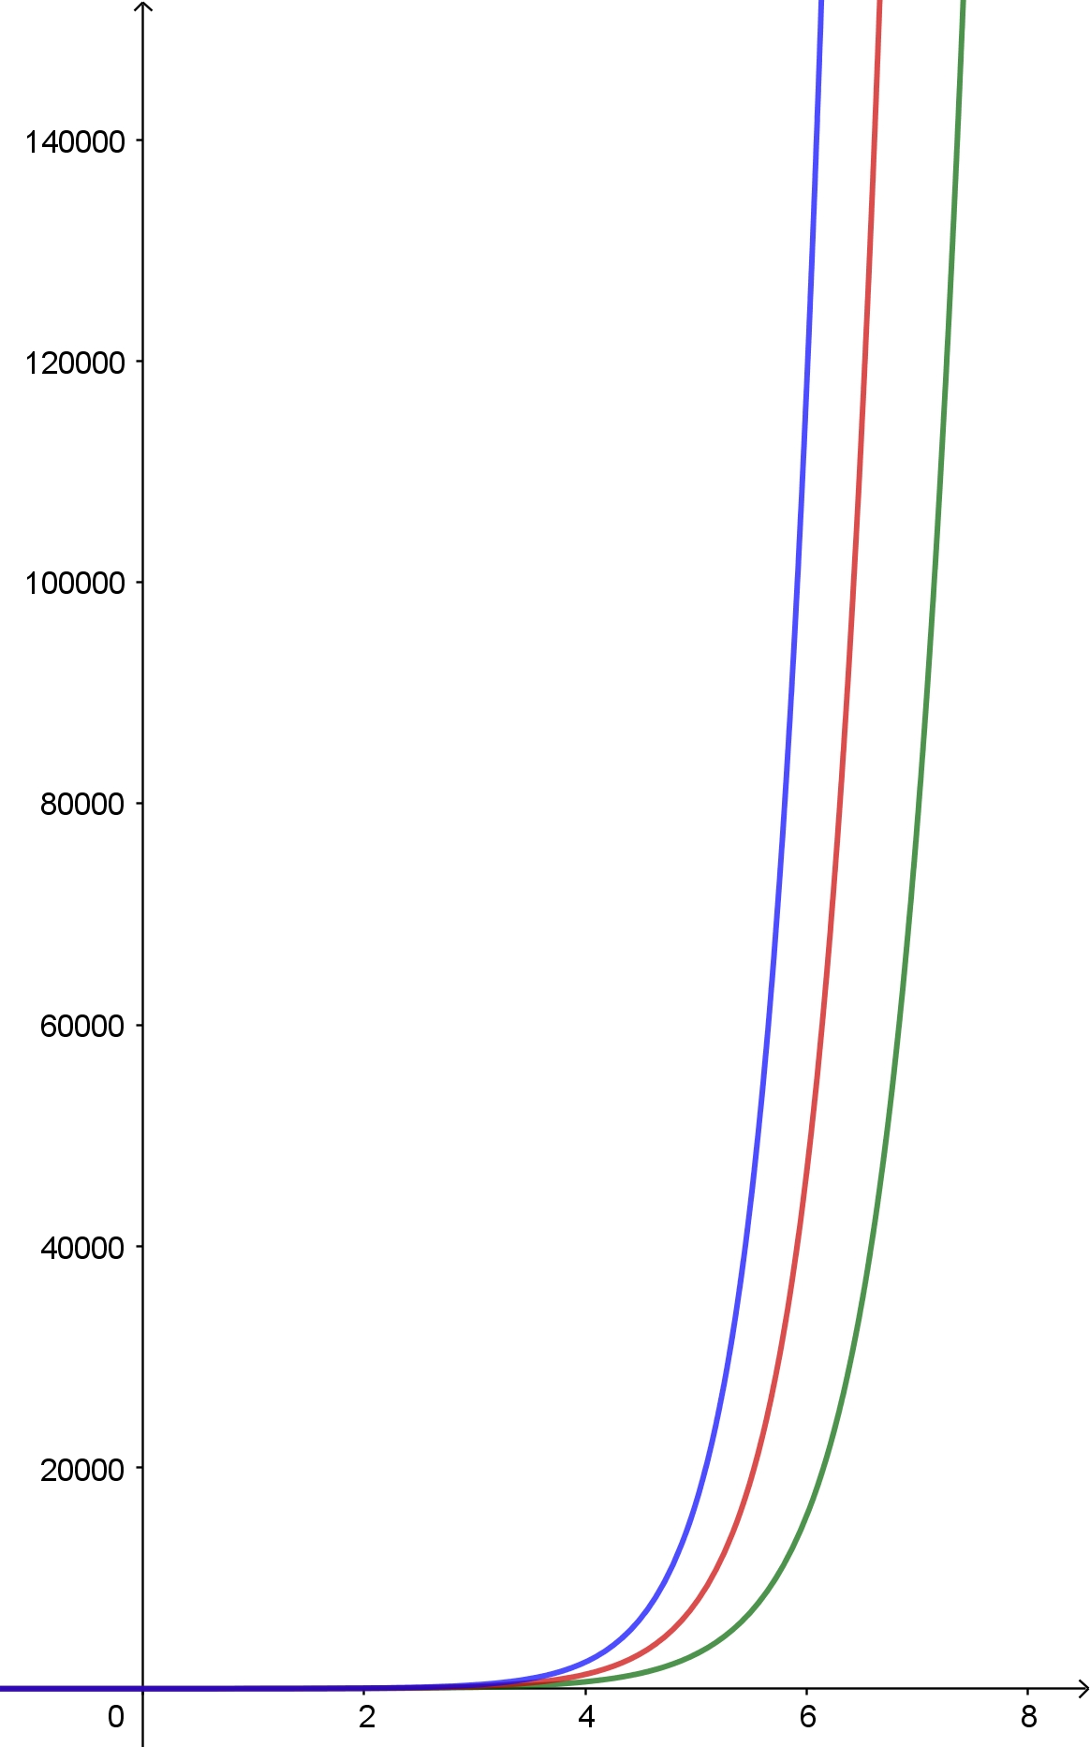

Once the slope is too steep, a reasonable evaluation of the graph is no longer possible. One solution is to choose a different scaling of the y axis. Usually, equal differences between y values are displayed as tick marks at equal distances on the y axis. This is a valid design, since, for linear growth (i.e., a linear function), the increase in the y value is always the same. For non-linear growth, e.g., exponential growth, where the difference between y values becomes larger with increasing x values, the semi-logarithmic scale to base 10 is useful. Here, the x axis remains unchanged, while the distances between increasing y values become smaller.

Background information on the semi-logarithmic scale to base 10
On the non-linear-scaled y axis, y values that differ by the same factor are displayed at equal separations. Thus, y values of 1, 2, 4, 8, …, all separated by a factor of two, are separated on the y axis by distances of $\log_{10}{2}≈0.301$. For y values of 1, 3, 9, 27, …, all separated by a factor of three, separations on the y axis are at a distance of $\log_{10}{3}≈0.477$. In general, y values separated by a factor of p are separated on the y axis by a distance of $\log_{10}{p}$. This results in tick marks that are no longer equidistance, but the distances between increasing y values become smaller.

A coordinate system that fulfils the above conditions is shown below on the left. As a result of semi-logarithmic scaling, the tick marks become denser at larger y values. This problem is overcome in the coordinate system shown below on the right, where the displayed steps between y values change once the y value reaches another power of ten.

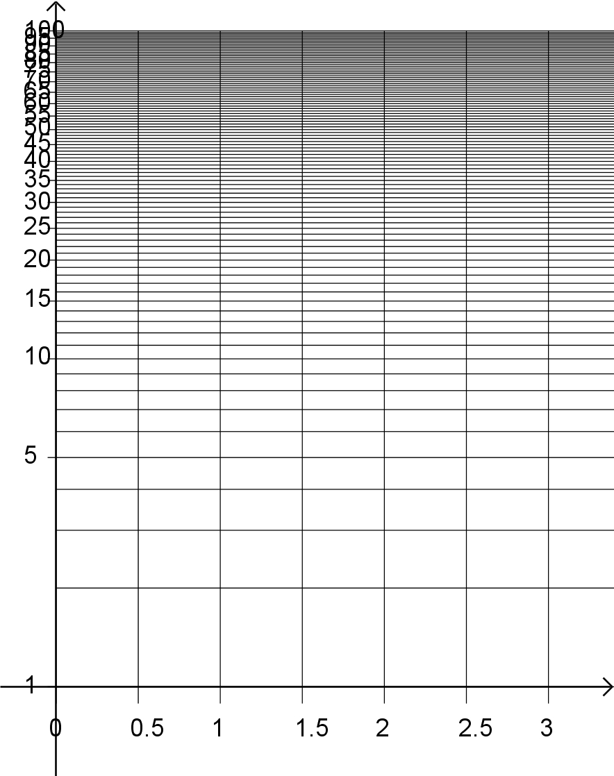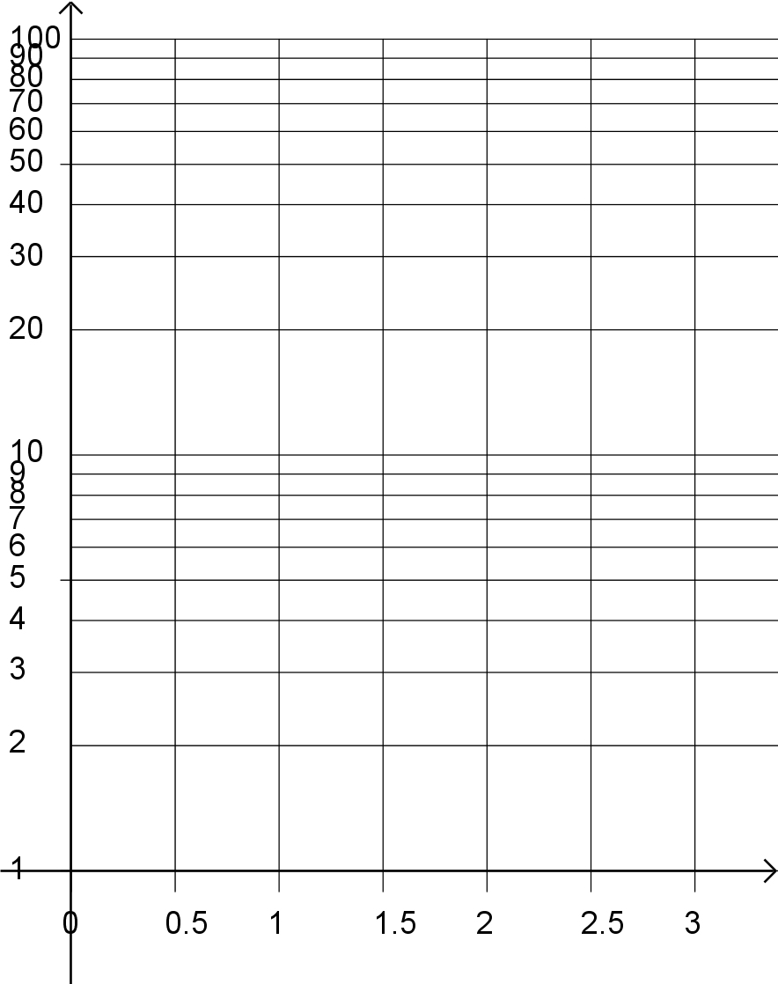

- To realize the advantages of this coordinate representation, complete the table below and transfer the datasets to both the linear coordinate system and to the semi-logarithmic coordinate system.
x | 1 | 2 | 3 | 4 | 5 | 6
$$y=5^{x}$$
$$y=7^{x}$$
$$y=8400x$$

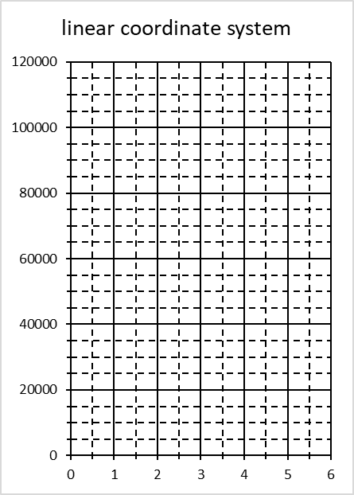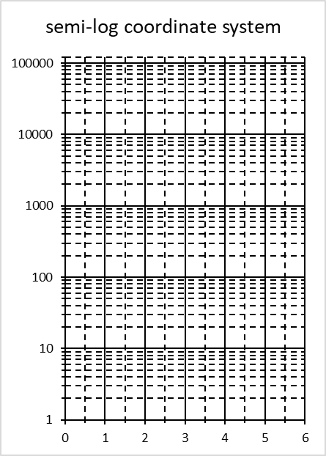

- Discuss the slopes of the graphs in the semi-logarithmic coordinate system.

Logarithmic scales in everyday life
Logarithmic scaling of the y axis is common whenever a graph resembles an exponential function.
Many human sensory perceptions are not processed linearly by our nervous system, but on a logarithmic scale. The relationship between a stimulus, for example, acoustic intensity, and its perception, i.e., loudness, is logarithmic. This enables humans to perceive a very wide range of sound levels: the ratio of intensities between silence and the threshold of pain is about 1:${10}^{12}$. The decibel scale (dB) is a logarithmic scale used to measure sound intensity. In decibel terms, a doubling in loudness corresponds to roughly an increase in 10 dB, regardless of the initial value, as illustrated below. This also means that the difference in stimulus that can be measured depends strongly on the strength of the stimulus. In silence, for example, a very quiet sound can be heard, whereas the same difference in loudness is no longer perceptible at room volume. The louder it gets, the bigger the difference in volume necessary for detection.

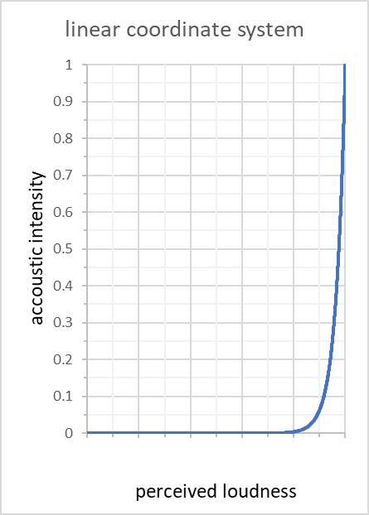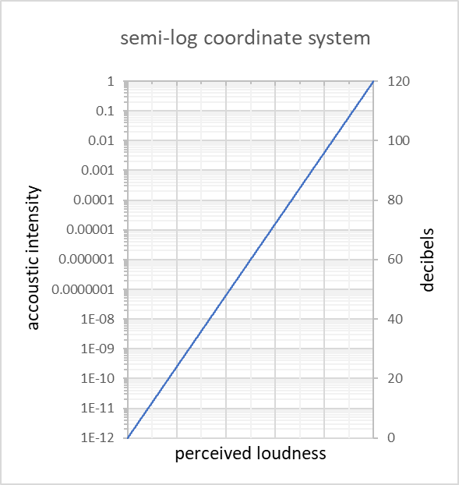
quiet
loud
quiet
loud
Logarithmic scales are also used to measure the strength of earthquakes (Richter scale), to determine pH values of aqueous solutions, and to count f stops for ratios of photographic exposure.
While plotting data on a semi-logarithmic scale can make it easier to compare datasets with a very wide range, care must be taken during interpretation because the relationships are no longer intuitive. On the Richter scale, for example, the difference between earthquakes of magnitudes 1 and 2 is much smaller than the difference between earthquakes of magnitudes 5 and 6. This can cause confusion in reporting. For example, early in the COVID-19 pandemic, the case rates for different countries were often compared on a semi-logarithmic scale and logarithmic growth appeared linear. Because the public is not familiar with this type of scale, many people thought that infection rates were lower than they actually were and may have been less willing to follow lockdown measures as a result.

Extension Activity 2 – COVID-19 spread in a more realistic simulation
The percentage of people who are already immune (through vaccination or recovery from the disease) in the total population also affects the R value, since this corresponds to a particular type of physical distancing, and thus, reduces the spread of the virus. Considering these people is more complicated, since this group becomes larger over time, i.e., this parameter is time-dependent. The reproduction number becomes smaller as the number of those immune increases. Such a scenario can be simulated with the SIR model, where S stands for susceptible individuals, I for infected individuals, and R for recovered individuals. During the simulation, the current numbers of S, I, and R individuals are calculated and their influence on all three groups is taken into account.
The value of S changes over time, as these individuals become infected over time. How many become infected depends on the probability that people from groups I and S will meet and become infected, so it depends on S, I, and the transmission rate ($β$). $β$  is linked to the known quantities R₀, D, and total number of people (N) in the simulation: $β=R_{0}/(D∙N)$. The rate, $\frac{∆S}{∆t}$, at which S changes with time t is calculated as follows:
$$\frac{∆S}{∆t}=-β∙S∙I$$
The value of I changes with time, because new people are infected (see change of S) and those infected recover to become immune (γ).γ is linked to the known quantity D, which indicates how long a person is infectious: γ = 1/D. The rate, $\frac{∆I}{∆t}$, at which I changes with time t is calculated as follows:
$$\frac{∆I}{∆t}=β∙S∙I-γ∙I$$
The value of R changes with time because recovered people from I are added. The rate, $\frac{∆R}{∆t}$, at which R changes with time t is calculated as follows:
$$\frac{∆R}{∆t}=γ∙I$$
The three equations can be solved simultaneously using the small-steps method in an Excel sheet and the course of the pandemic can be followed.
The equations are discretized as shown below, where n denotes the current time step and n−1 is the previous time step:
$$\frac{∆S}{∆t}=-β∙S∙I→\frac{S\left(n\right)-S\left(n-1\right)}{∆t}=-β∙S(n-1)∙I(n-1)$$
$$\frac{∆I}{∆t}=β∙S∙I-γ∙I→\frac{I\left(n\right)-I\left(n-1\right)}{∆t}=β∙S\left(n-1\right)∙I\left(n-1\right)-γ∙I(n-1)$$
$$\frac{∆R}{∆t}=γ∙I→\frac{R\left(n\right)-R\left(n-1\right)}{∆t}=γ∙I(n-1)$$

Thus, S, I, and R values of the current time step are calculated as follows:
$$S\left(n\right)=S\left(n-1\right)-β∙S(n-1)∙I(n-1)∙∆t$$
$$I\left(n\right)=I\left(n-1\right)+\left[β∙S\left(n-1\right)∙I\left(n-1\right)-γ∙I(n-1)\right]∙∆t$$
$$R\left(n\right)=R\left(n-1\right)+γ∙I(n-1)∙∆t$$

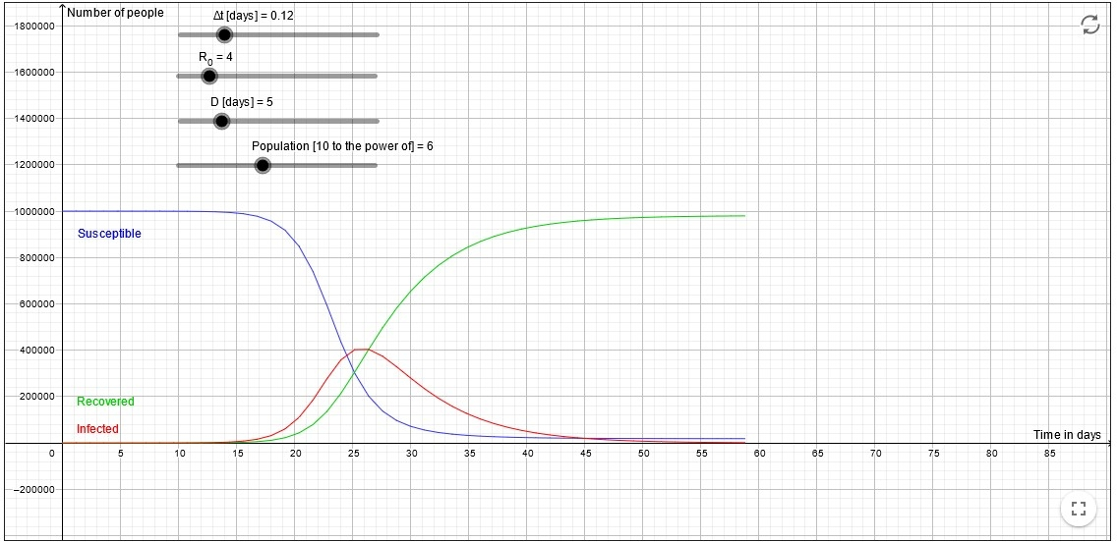
Use the Geogebra App to simulate the course of the pandemic with known R₀ and D values for a city of 100 000 or 1 000 000 inhabitants or a country of 100 million inhabitants. You may need to adjust the time step, Δt.
Created with GeoGebra

Image courtesy of Wolfgang Vieser, Copyright: © International GeoGebra Institute, 2013
For each case, calculate the time when the maximum number of infected people is reached. What percentage of people have not been infected at that time?

Solutions:

Activity 1
- The green graph corresponds to R = 5, the red one to R = 6, and the blue one to R = 7.
- The table should look like this:
x | 1 | 2 | 3 | 4 | 5 | 6
$$y=5^{x}$$ | 5 | 25 | 125 | 625 | 3125 | 15 625
$$y=7^{x}$$ | 7 | 49 | 343 | 2401 | 16 807 | 117 649
$$y=8400x$$ | 8400 | 16 800 | 25 200 | 33 600 | 42 000 | 50 400

- The graphs should look like this:
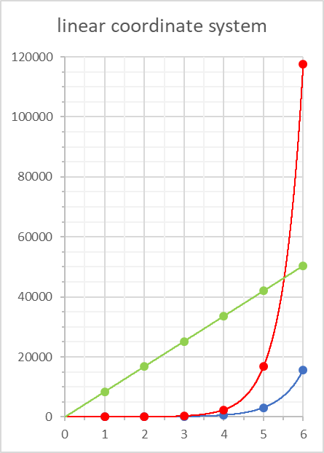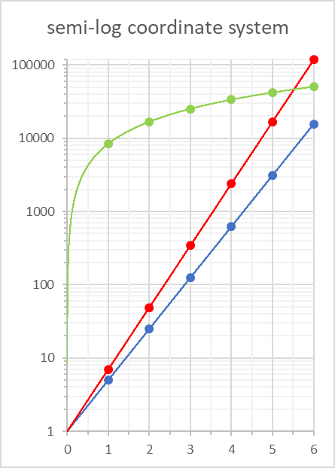
In the semi-logarithmic coordinate system, the slopes of the exponential functions are constant with increasing slope values for higher bases. The linear function shows a decreasing slope, which could lead to the misconception that the increase in numbers also decreases.

Activity 2
The pandemic has maximum numbers of infected people at 22, 26, and 34 days, respectively.
At these time points, only 25% of the population is not yet infected. When so few people are left without immunity, the pandemic almost disappears by itself. Society is said to have achieved herd immunity once 75% of the population are immune.

