Science (and more) crossword

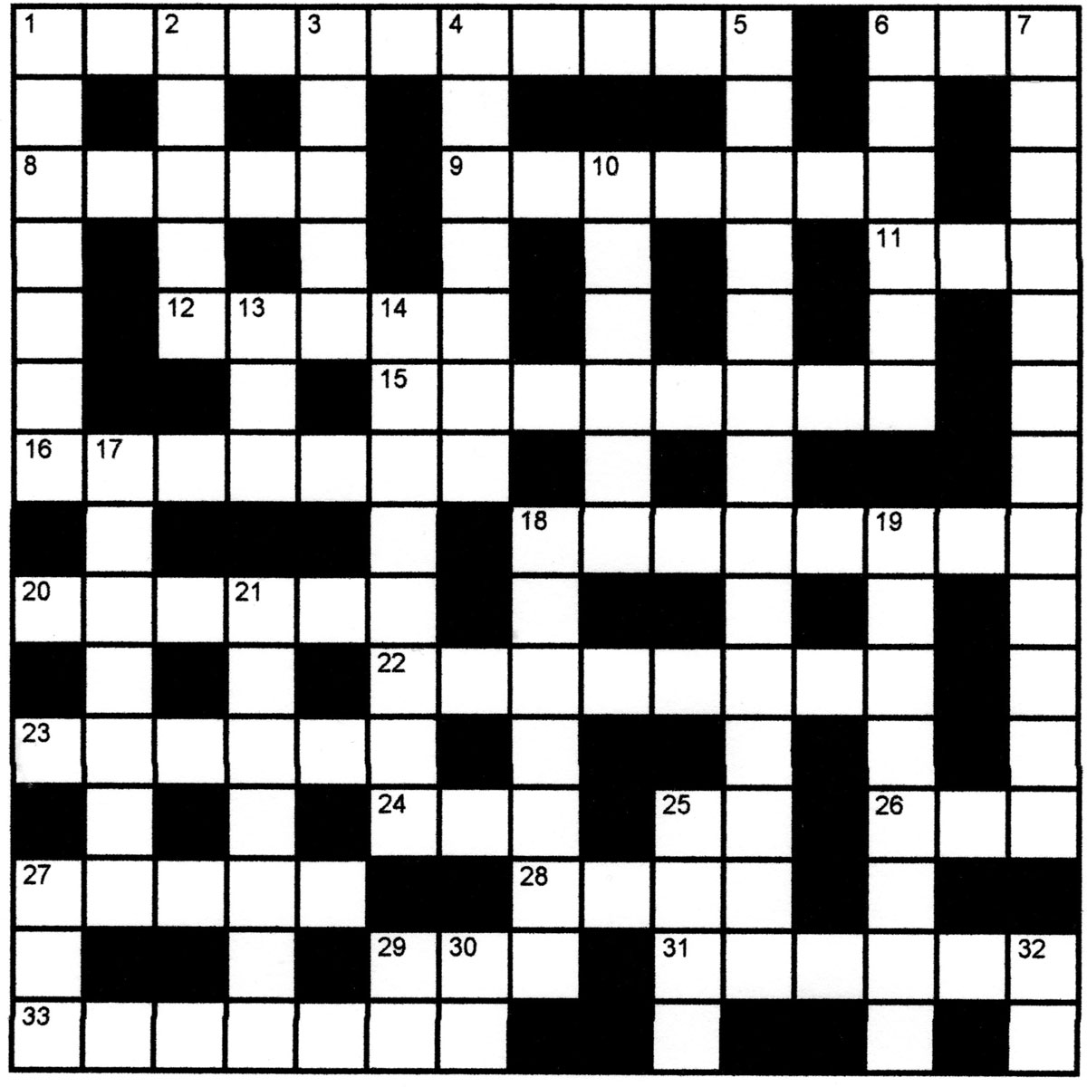

Clues

Across
1. The change from liquid to vapour (11)
6. A diode that emits light (initials) (1,1,1)
8. Number of protos in an oxygen atom (5)
9. A continuous path for an electric current (7)
11. You do this to acquire a store of personal energy (3)
12. The direction in which a compass points (5)
15. Deposits of sodium chloride in the earth (4,4)
16. Relating to heat (7)
18. Country bordered by Kenya, Sudan and Somalia (8)
20. Use these to attach items to laboratory stands (6)
22. The liquid that passes through the filter paper (8)
23. Set fire to (6)
24. Tear or shred (3)
25. Symbol for element 14 (2)
26. The Earth’s main source of energy (3)
27. Small blood-sucking flies (5)
28. Very large closed container for the storage of grain etc. (4)
29. A baked dish with a pastry top (3)
31. It’s defined as the ability to do work (6)
33. The longest river in Ireland (7)

Down
1. Substance containing only one kind of atom (7)
2. One of the noble gases (5)
3. This shell contains the electrons that can be lost or shared (5)
4. An organic compound containing an –OH group, sometimes used in thermometers (7)
5. The reaction of an acid with an alkali (14)
6. Hidden, as is the heat energy in steam (6)
7. The process of boiling and recondensing to separate or purify (12)
13. Use this to row a boat (3)
14. Electrons do this to form ionic bonds (8)
17. Collective name for any Group 7 element (7)
19. Force per unit area (8)
18. The masking of one astronomical body by another
21. Make slightly damp (7)
25. A simple toboggan or sledge (4)
27. One of the states of matter (3)
29. Symbol for a radioactive element discovered by Marie Curie (2)
30. Symbol for element 49 (2)
32. Symbol for element 70 (2)

