Look out! The physics of road safety

Pedestrian collisions

When pedestrians are hit by vehicles, the injuries they suffer and the way they are thrown can provide evidence about what happened in the collision.
Direct frontal impacts are those in which the pedestrian is struck by any part of the front of the vehicle, other than the corners.
In a direct frontal impact, the direction and distance in which the pedestrian is thrown depends on a variety of factors, including:
- the point of impact between the pedestrian and vehicle
- the vehicle’s rate of braking.
- the size and shape of the vehicle
- the speed of the vehicle.

Point of impact
In the case of an impact involving a car or other small vehicle, pedestrians are not normally ‘run over’, but are in effect ‘run under’. This is because, if the first point of contact with the vehicle is below the pedestrian’s centre of gravity (usually about the navel), the person is thrown upwards and the vehicle passes under the pedestrian.

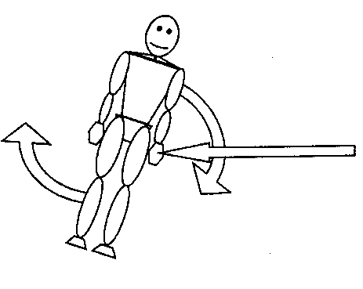
Person is thrown upwards
Pedestrian is hit below their centre of gravity
Police Scotland

However, if the initial contact strikes the pedestrian above their centre of gravity, the pedestrian will be pushed downwards and will then be run over by the vehicle. Such situations are comparatively rare with cars and small vans unless the pedestrian is a child, or is small in stature or lying in the road before impact.
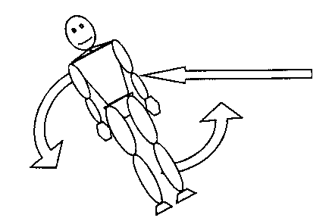
Pedestrian is hit above their centre of gravity
Police Scotland

Person is pushed downwards

The final resting place of the casualty in respect to the vehicle can assist in determining whether or not there was braking at impact.

Vehicle braking
At impact, the pedestrian is accelerated up to the speed of the vehicle. If the vehicle brakes during the impact (which is the most common situation), the vehicle slows down faster than the pedestrian (because it is braking and the pedestrian is not), so the pedestrian will be thrown through the air ahead of the slowing vehicle, coming to rest after striking the ground.
However, if there is no braking during the collision, or braking does not occur until a very late stage, the pedestrian may pass over the top or down the side of the vehicle rather than being projected in front of it. Each of these separate contacts with the vehicle and ground can, and frequently does, cause injury.

Vehicle size
The size and shape of the vehicle also makes a difference. If the vehicle is large, such as a lorry or a bus, once the pedestrian is accelerated to the speed of the vehicle, there is no route for the person to be thrown off, other than in the direction of travel of the vehicle. If the vehicle brakes, the pedestrian will be projected forward and will land some distance in front of the vehicle. If there is little or no braking, the vehicle is likely to catch up with the pedestrian, who will probably be run over.

Vehicle marks and pedestrian contact
The illustrations below show the relationship between the pedestrian impact and the marks left on the car. The line formed by the marks would not normally be as obvious as those shown here, but they could still give clues as to how the pedestrian was hit and thrown, when added to other evidence, such as the injuries to the person and where the person lands after being thrown during the collision.
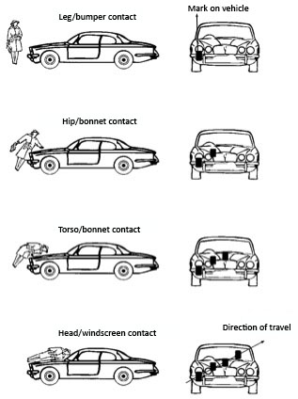
Police Scotland

