Grasping the resting potential – Experiment 2: Diffusion through a membrane

Task 1
Please read the information below and familiarise yourself with the concept of diffusion.

Information
All types of molecules are constantly in motion and strive to distribute themselves equally in a given medium. This phenomenon is commonly referred to as diffusion. Molecules move more quickly at higher temperatures than at lower ones, and they can diffuse through a membrane as long as it is permeable for that type of molecule.
Phenolphthalein is chemical compound that is commonly used as an indicator. At lower and intermediate pH levels, it is colourless, but at higher (alkaline) pH levels, it turns pink. In terms of its molecular structure, it is fairly large.

Experiment
*Gloves and lab coats must be worn throughout the entire experiment.
Materials | Hazards
Sodium hydroxide solution (1 mol/l) | Causes severe chemical burns.  Use protective glasses and gloves when handling.
Phenolphthalein | Hazardous to health. Do not swallow. Use protective clothing when handling.
Purified water
Glass cylinder with rounded edges
Cellophane wrapping
Rubber band
Stand and clamp
Pipettes
Lab coats, gloves and protective glasses
Beaker

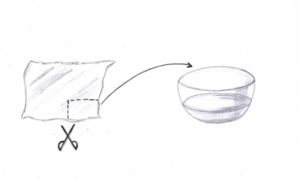
Procedure
- Cut the cellophane to fit the opening of the cylinder and soak it in purified water to make it more flexible.
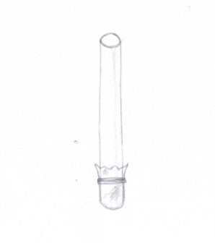
- Tightly but carefully wrap the cellophane over the opening of the cylinder and use the rubber band to secure it.

- Fasten the glass cylinder vertically to the stand with a clamp, so the cellophane is at the bottom.

- Dissolve a few drops of phenolphthalein in 70 ml of purified water. Carefully pour the solution into the glass cylinder until it is half full.

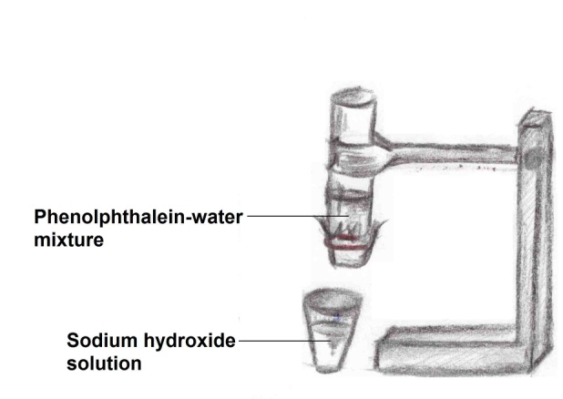
- Put about 100 ml of the sodium hydroxide solution into a beaker and place it directly underneath the glass cylinder

- Lower the cylinder into the sodium hydroxide solution. What do you think will happen with the two solutions? Write your hypothesis in the box below.

Hypothesis

Task 2
Use the box below to record your observation after conducting the experiment. Afterwards, discuss with your group how your results can be explained.

Observation

Conclusion
What do you think is the explanation for your results? Try to include the cellophane’s properties in your conclusion and write it in the box below.

Conclusion

