Collaborative activity: calculating the circumference of Earth
Around 240 BC, the ancient Greek mathematician Eratosthenes calculated the circumference of Earth. He based his calculations on the angle of elevation of the Sun at noon on the June solstice at two locations in Egypt of known distance apart. In a collaborative activity with another school, your students can repeat his calculation using smartphones. The further apart the two schools are, the more accurate the calculation will be.
While working at the famous library of Alexandria, Eratosthenes noticed reports that in Syene (now Aswan), which is on the same meridian as Alexandria but about 800 km to the south, the Sun appeared directly overhead at noon on 21 June. In Alexandria, in contrast, a large obelisk cast a shadow at noon. Measuring the angle of the shadow (7.2° or 1/50 of a circle), Eratosthenes determined the angle between Alexandria and Syene (the difference between their latitudes) and from that calculated the circumference of Earth.
For our calculations, the two locations need not be on the same meridian but this means we have to consider their longitude difference, which in practice means taking the measurements not at the same time, but at solar noon at each location.

Materials
Each group of students will need:
- Smartphone with an inclinometer app and a planetarium app installed

Procedure
Ask your students to:
- Check the weather forecast for both locations to select a clear day on which to perform the experiment.
It does not matter at which time of the year your students take the measurements, because we are concerned with comparative rather than absolute altitudes.
- Use the planetarium app to determine the exact time of solar noon at each location.
- Using, for example, Google Maps, find the north-south distance between the two locations (the distance between the circles of latitude).
- On the appointed day, determine the altitude of the Sun at solar noon at each location, as described in the first activity.
- Calculate the circumference of Earth using the following equations:
Angular distance / 360° = distance between the locations’ latitudes / circumference of Earth Equation 3
Rearranged:
Circumference of Earth = distance between the locations’ latitudes x 360° / angular distance Equation 4

Discussion
Ask your students to use the planetarium app to look up the altitude of the Sun at solar noon at each location. How accurate were their measurements? What estimate of Earth’s circumference do they get if they use the figures from the planetarium app?
According to our planetarium app, we should have measured a noon altitude of 72.2° in Tarragona and 67.7° in Lyon, with an angular distance of 4.5°. Google Maps tells us that the two locations are 495 km apart. This gives:
495 km x 360° / 4.5° = 39 600 km
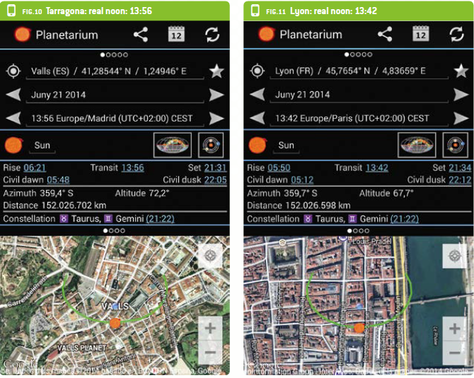
Figure 10: Tarragona and Lyon in a planetarium app
Image courtesy of Philippe Jeanjacquot and Pere Compte
If the inclinometer app allows a slope angle to be measured with an accuracy of 0.1°, what error could this introduce to your students’ estimate of Earth’s circumference?
If our readings had been 72.3° in Tarragona and 67.6° in Lyon (an angular difference of 4.7°), this would have given:
495 km x 360° / 4.7° = 37 914 km
Thus the accuracy of 0.1° introduces an error of nearly +/- 1700 km.
Today, the circumference of Earth is known to be 40 075 km at the equator, so our measurement resulted in an error of 475 km, or about 1%. If we consider the accuracy of the smartphone’s inclinometer app (0.1°), we can expect an error of +/- 2000 km, or about 5%. This is similar to the accuracy achieved by Eratosthenes more than 2000 years ago. This not only highlights how impressive Eratosthenes’ achievement was, but also demonstrates the importance of precise measuring devices.

