Science in School – issue 29
Become a water quality analyst
Worksheet 1: The scenario

You are a quality analyst from a small independent quality control firm and your role is to ensure that the results meet the requirements of the UK Environment Agency.

The effluent of an industrial plant such as the Tata Steel site in Scunthorpe is known to contain around 250 mg/dm³ of thiocyanate ions. However, the safe level given by the Agency is 10 mg/dm³. The effluent is treated so that the thiocyanate concentration is reduced to 1mg/dm³ – well below safe limits. The thiocyanate ions are removed from the effluent before it is fed into the River Trent.

There has been a recent period of severe cold weather which can affect the activity of micro-organisms. The company is concerned that this has affected its water treatment plant and has reduced its effectiveness at removing thiocyanate ions from waste water.

The water is normally analysed for thiocyanate at the plant three times a day using a simple test: an acidic solution of iron(III) chloride is added to the water sample and the concentration of thiocyanate is measured photometrically by measuring the absorbance due to the iron(III) thiocyanate complex. A total of 16 separate tests are carried out every week. Samples of incoming effluent and the water ready for discharge into the river are also taken back to the laboratory for accurate analysis.

The company’s analysts have checked, but the company is seeking an independent analysis. You have been asked to investigate.

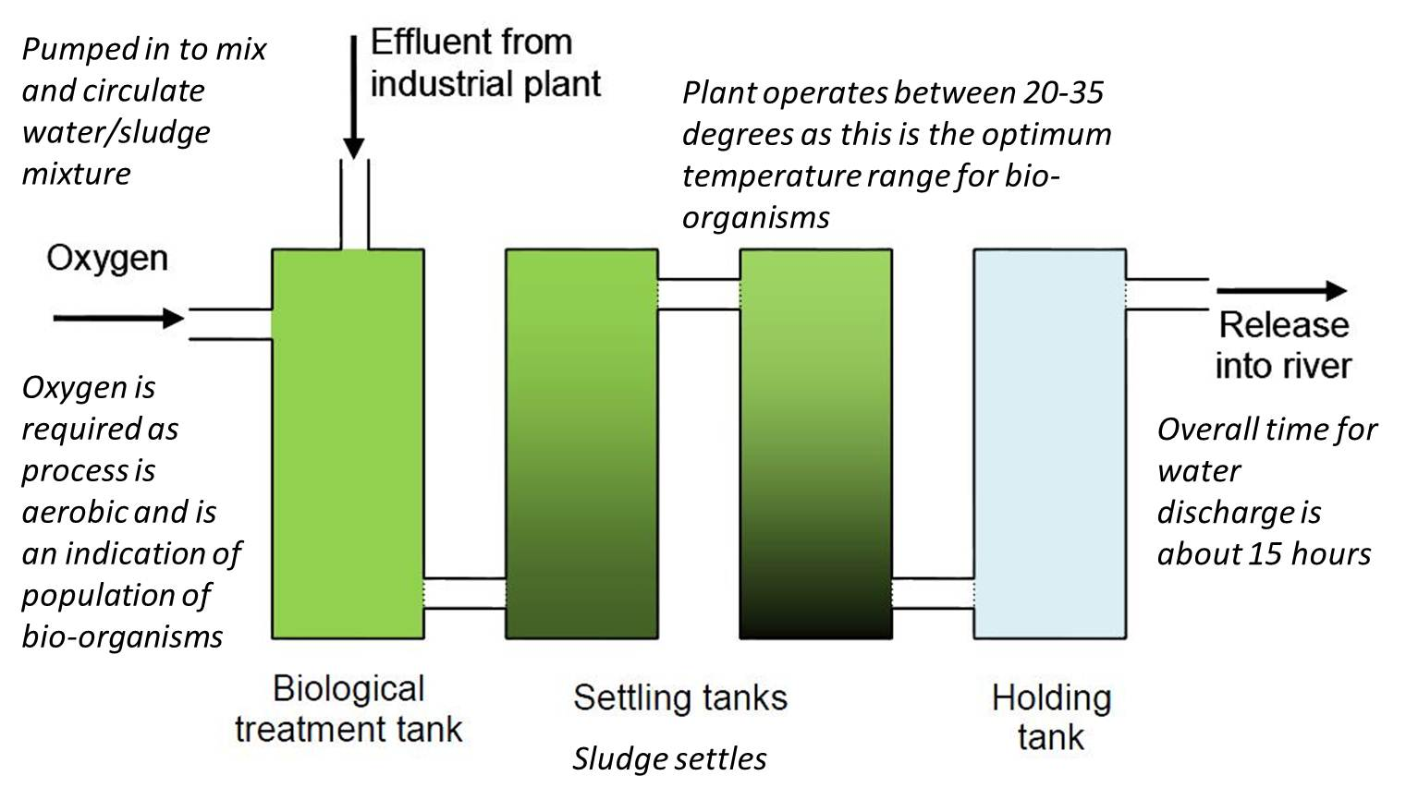

What you need to do:

- Study the plan of the waste water treatment plant (figure 3).

- Write a letter to the company that operates the plant, requesting samples that you need for analysis. You should specify at what point in the flow of effluent through the plant you would like samples to be taken, how many samples you require and when they should be taken. You should also specify the quantity of each sample needed, how they should be taken and in what kind of container they should be collected.
- When you receive the appropriate samples, use the method described in worksheet 2 to find out how effective the treatment of the waste water is so that you can decide whether the treated effluent may be fed into the nearby river.

- Write a report to the company summarising your work and including a recommendation about whether the effluent should be fed into the river. Describe the evidence on which your recommendation is based and comment on the confidence you have in your results, taking account of the percent error that may be involved in your analysis. You may give further advice on how to proceed should the samples be outside the safe range.

